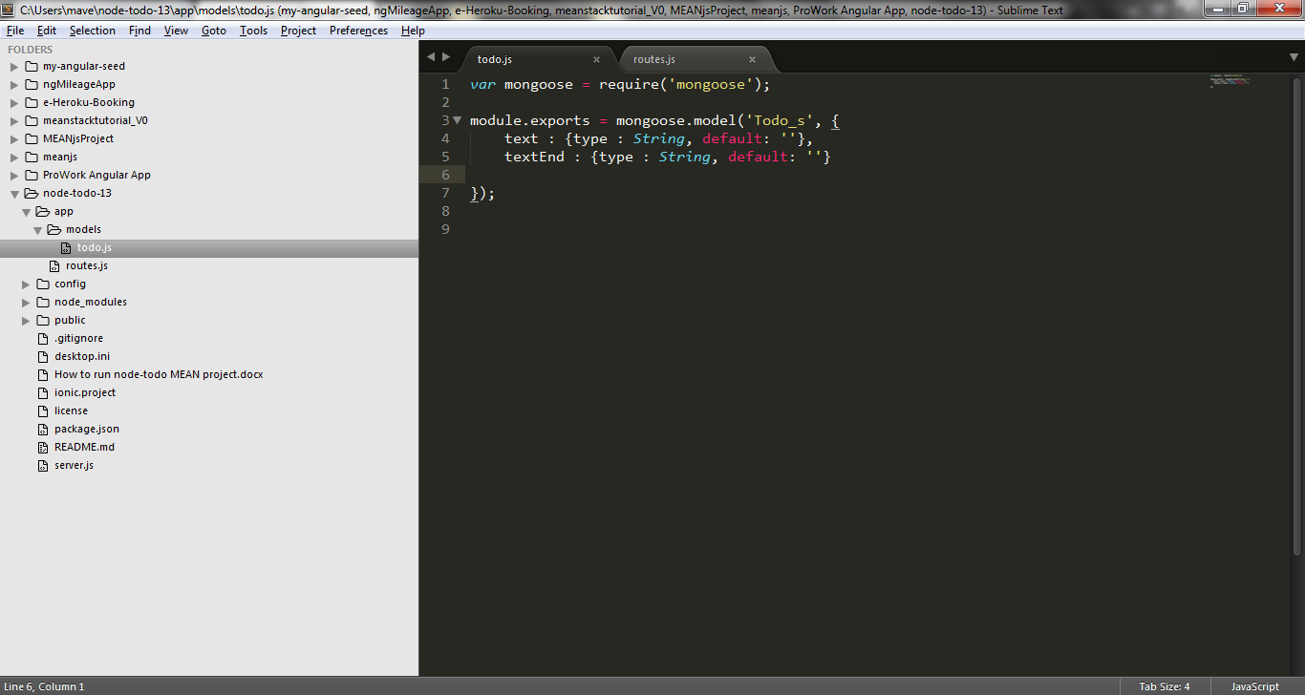

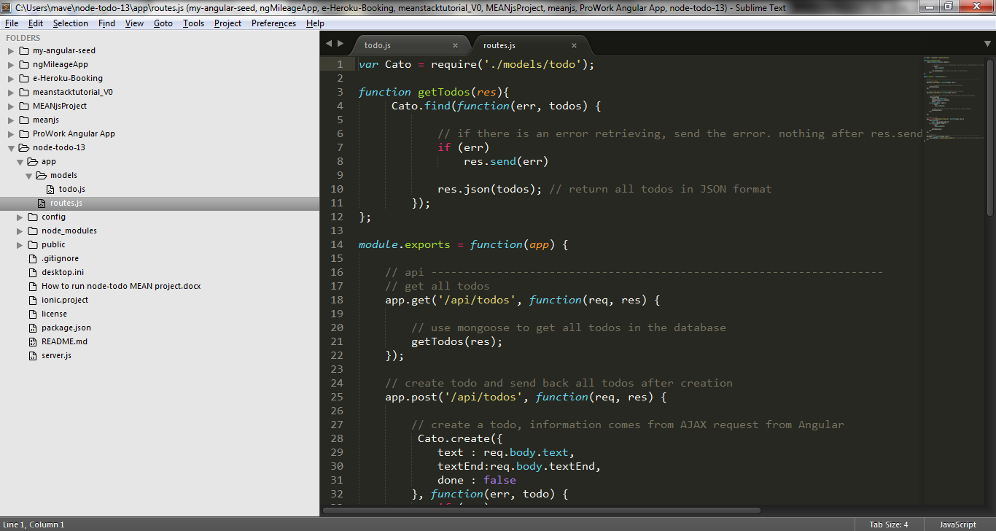

Mongoose model name in todo.js doesn’t have to as the same as it shows on routs.js (in express).